MS SQL SERVER
Standard Operating Procedures
(SOP)
Configure SQL Server Database Mirroring

Submitted to



By



CIS, Wipro Limited

Document Details

Project Name | Innogy SE
Account | CIS
IT Component/Application Title | Configure SQL Server database Mirroring.
Current Version | 1.2
List of Contributors | Pradipkumar Kansara, Kiran Bhalekar, Ayushi Gautam, Sivakumar Goud, Pramod Patil
Customer Contact Information

Version History
(All revisions made to this document must be listed in chronological order. All revisions must be approved. Review and Approval can be done by an internal source or by the customer)
Version | Date of Revision | Description | Author | Reviewed By | Approved By
1.0 | 05-12-2017 | Initial Draft | Sivakumar Goud | Pradipkumar Kansara | Santosh Badiger
1.1 | 06-12-2017 | Document Submitted | Sivakumar Goud | Pradipkumar Kansara | Santosh Badiger
1.2 | 10-11-2018 | Updated the content | Pramod Patil | Pradipkumar Kansara | Santosh Badiger

Document Distribution List
S.No | Name and Company | Purpose
1 | RWEIT-SQLDBA | Document is help full for configuring SQL Server database Mirroring.

TABLE OF CONTENT
1. Purpose 4
2. Scope
3. Prerequisites for configuring database Mirroring ………………………………………………………….4
4. Restrictions……………………………………………………………………………………………………………4

5. Database Mirroring Concepts ……………………………………………………………………………..5

6. Types and Operating modes in Mirroring……………………………………………………………..6

7. Steps to Configure SQL Server database Mirroring……………………………………………..7

1. Purpose

This document is prepared for the concept of Configure SQL Server2014 database Mirroring in SQL Server database administration services.

2. Scope
This document is prepared for SQL Wipro sustenance team and provides the concept of Configure SQL Server database Mirroring for SQL Server database.

3. Prerequisites for configure SQL Server database Mirroring.

For a mirroring session to be established, the partners and the witness, if any, must be running on the same version of SQL Server.
- The two partners, that is the principal server and mirror server, must be running the same edition of SQL Server. The witness, if any, can run on any edition of SQL Server that supports database mirroring.

The database must use the full recovery model. The simple and bulk-logged recovery models do not support database mirroring. Therefore, bulk operations are always fully logged for a mirrored database.
- Verify that the mirror server has sufficient disk space for the mirror database.
- When you are creating the mirror database on the mirror server, make sure that you restore the backup of the principal database specifying the same database name WITH NORECOVERY. Also, all log backups that were created after that backup was taken must also be applied, again WITH NORECOVERY.
4. Restrictions.
- Only user databases can be mirrored. You cannot mirror the master, msdb, tempdb, or model databases.
- A mirrored database cannot be renamed during a database mirroring session.
- Database mirroring does not support FILESTREAM. A FILESTREAM file group cannot be created on the principal server. Database mirroring cannot be configured for a database that contains FILESTREAM file groups.

5. Database Mirroring Concepts
Principal: In a database mirroring configuration, there are two copies of a single database, but only one copy is accessible to the clients at any given time. The copy of the database that the applications connect to is called the principal database. The server that hosts the principal database is known as the principal server.
Mirror: The mirror is the copy of the principal database. The mirror is always in a restoring state; it is not accessible to the applications. To keep this database up-to-date, the log records are transferred from the principal and applied on the mirror database. The server that hosts the mirror database is known as the mirror server.
Witness: The optional witness is an SQL Server instance in a database mirroring configuration. It is separate from the principal and mirror instances. When database mirroring is used in synchronous mode, the witness provides a mechanism for automatic failover.
Send Queue: While sending the log records from the principal to the mirror, if the log records can’t be sent at the rate at which they are generated, a queue builds up at the principal. This is known as the send queue. The send queue does not use extra storage or memory. It exists entirely in the transaction log of the principal. It refers to the part of the log that has not yet been sent to the mirror.
Redo Queue: While applying log records on the mirror, if the log records can’t be applied at the rate at which they are received, a queue builds up at the mirror. This is known as the redo queue. Like the send queue, the redo queue does not use extra storage or memory. It exists entirely in the transaction log of the mirror. It refers to the part of the hardened log that remains to be applied to the mirror database to roll it forward.
Endpoint: An endpoint is a SQL Server object that enables SQL Server to communicate over the network. It encapsulates a transport protocol and a port number.
Failover: When the principal database (or the server hosting it) fails, database mirroring provides a mechanism to fail over to the mirror database.

6. Types and Operating modes in Mirroring

Below are two operating modes in Mirroring.
- Synchronous Mirroring
- Asynchronous Mirroring
Synchronous Mirroring.
- In all SQL Server databases, data changes are recorded in the transaction log before any changes to actual data pages are made. The transaction log records are placed first in a database’s log buffer in memory, and then flushed to disk (or ‘hardened’) as quickly as possible. In database mirroring, as the principal server writes the principal database’s log buffer to disk, it simultaneously sends that block of log records to the mirror instance. The mirror receives the log records in mirror database’s log buffer and then hardens them to disk as quickly as possible.
- In Synchronous mirroring, as soon as data is committed in the principal it is sent to the mirror server and it is also committed there. After that the mirror sends an Acknowledgement to principal that data has been committed there. The key concept is that the client i.e principal waits until it receives an Acknowledgement from mirror before it commits the next set of data’s.
- If the network is slow, it will definitely cause performance issues because the principal is waiting for receiving an Acknowledgement to proceed with subsequent transactions. This is the most secure method for assuring that data is absolutely correct between principal and mirror but it is also the slowest method due to overhead of the principal having to wait for the Acknowledgement to be sent back.

- High Availability: This operating mode option allows you to synchronize transaction writes on both servers and enables automated failover. For this option to work, you must also have a witness server.
- High Protection: This option allows you to synchronize transaction writes on both servers, but failover is manual. Since automated failover is not part of this option, a witness server is not used.

Asynchronous Mirroring.
The data that is committed in the principal is sent to the mirror but the principal does not wait for any Acknowledgement from mirror server before continuing with the other transactions. The transactional consistency between the principal and mirror might vary slightly. The mirror database might receive the log records after some time may be some 20 to 30 seconds depending on the transaction size and network speed.
High Performance: This option does not care if the writes are synchronized on both servers, therefore offering some performance gains. When using this option, you are just assuming that everything is going to complete successfully on the mirror. This option only allows manual failover, and a witness server is not used.

7.Steps to Configure SQL Server database Mirroring
Step1:
- Issue a full backup of principle database by using below T-SQL script.
‘’Backup database [database name] to disk = ‘Path of the backup file’ ‘’
- Issue a Transaction log backup of principle database.
Backup log [database name] to disk = ‘Path of backup file’.
Step 2:
After taking the Full and Transaction log backup of principle databse. We have to copy backup file to mirrored server.
Now we need to restore the full backup and transaction log backup to the Mirror server with the NORECOVERY option.
After complete restore step mirror database should be in restoring state.

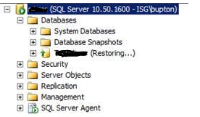

Step 3:
Now connect to principle server, right click the database and choose "Tasks" | "Mirror" or choose "Properties" | "Mirroring".
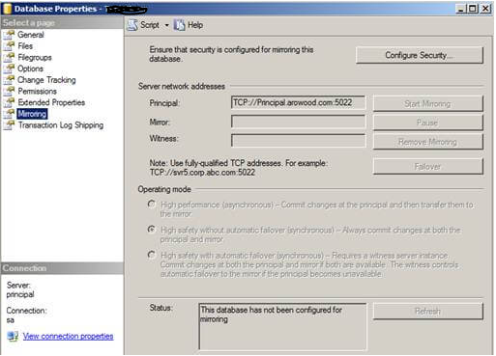
Click the "Configure Security" button and click "Next >" if the Configure Database Mirroring Security Wizard intro screen appears. The next screen should be the Include Witness Server screen:

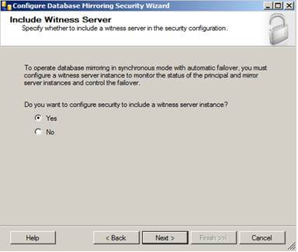
This is where you would configure a witness server for your mirroring, but since we're just configuring a basic mirror we will skip this part. However, if you are configuring mirroring in an Enterprise environment it is recommended you configure a witness server because without one you will not have synchronous automatic failover option.
Select "No", then click "Next >" to continue the process.
The next screen will give you options to configure the Principal Server Instance:
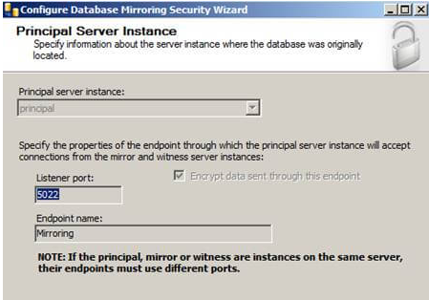
Here we will be creating our endpoint, which is a SQL Server object that allows SQL Server to communicate over the network. We will name it Mirroring with a Listener Port of 5022.
Click the "Next >" button to continue.
The next screen will give you options to configure the Mirror Server Instance:
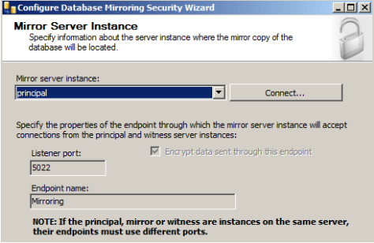

To connect to the Mirror server instance we will need to click the "Connect..." button then select the mirror server and provide the correct credentials:
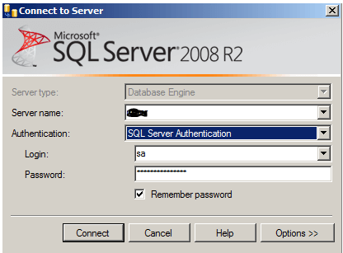
Once connected, we also notice our endpoint name is Mirroring and we are listening on port 5022.
Click "Next >" and you'll see the Service Accounts screen.
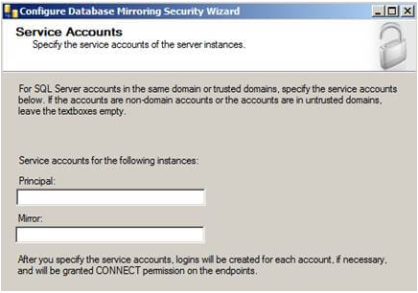

When using Windows Authentication, if the server instances use different accounts, specify the service accounts for SQL Server. These service accounts must all be domain accounts (in the same or trusted domains).
If all the server instances use the same domain account or use certificate-based authentication, leave the fields blank.
Since my service accounts are using the same domain account, I'll leave this blank.
Click "Finish" and you'll see a Complete the Wizard screen that summarizes what we just configured. Click "Finish" one more time.
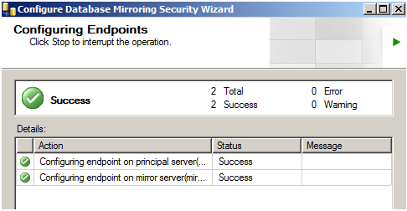
If you see the big green check mark that means Database Mirroring has been configured correctly. However, just because it is configured correctly doesn't mean that database mirroring is going to start...
Next screen that pops up should be the Start/Do Not Start Mirroring screen:
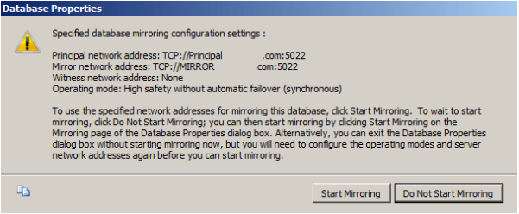
We're going to click Do Not Start Mirroring just so we can look at the Operating Modes we can use:
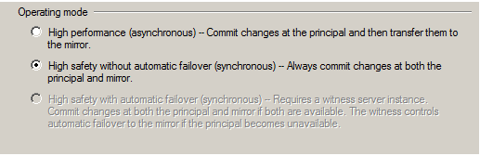
Since we didn't specify a witness server we will not get the High Safety with automatic failover option, but we still get the High Performance and High Safety without automatic failover options.
For this example, we'll stick with synchronous high safety without automatic failover so changes on both servers will be synchronized.
Next, click "Start Mirroring" as shown below.
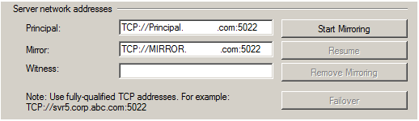
If everything turned out right, Database Mirroring has been started successfully and we are fully synchronized.

Above screen shot shows that boath principle and mirror databases are in fully synchronized.
To Verify the mirroring, Connect principle and mirror server. As shown below
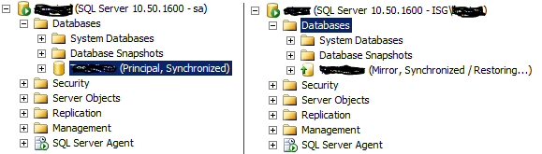
As per above screen shot boath databases are in synchronous state.

